ABC’s Inventory Management System

Test Script

Table of Contents

SPT001- Search Product Using Existing Product Code 3

Result Screenshots 3

Data Set 1 3

Data Set 2 5

SPT002- Search Product Using Unknown Product Code 7

Result Screenshots 8

Data Set 1 8

Data Set 2 10

SPT003- Search Product Using Existing Product Item Code 12

Result Screenshots 13

Data Set 1 13

Data Set 2 16

Data Set 3 19

SPT004- Search Product Using Unknown Product Item Code 22

Result Screenshots 23

Data Set 1 23

Data Set 2 25

Data Set 3 28

# SPT001- Search Product Using Existing Product Code

|  |  |  |  |  |  |
| --- | --- | --- | --- | --- | --- |
| **Test Name** | | Test Search Product Using Existing Product Code (Test Case SPT001) | | | |
| **Use Case Tested** | | Search Product | | | |
| **Test Description** | | This test tests if the system can retrieve product such as product code, product name, price, description. | | | |
| **Pre-Conditions** | | Meta data must exist, product and product details like product code, product name, price, description. | | | |
| **Post-Conditions** | | Matching product displayed through product code. | | | |
| **Notes** | | This test assumes that the user knows the product code exists.  This test allows users to view product items using a product code. | | | |
| **Result (Pass/Fail/Warning/ Incomplete)** | | Pass | | | |
|  | **Test Step** | | **Expected Test Results** | **P** | **F** |
| 1. | Select Search Product Button from home page | | Display the Search Product page | P |  |
| 2. | Type in the existing product code that is known by the user in the Product Code field of the system. | | System waits for the user to hit enter or click on the ‘Search’ button. | P |  |
| 3. | Hit enter or click on the ‘Search’ button. | | Product with matching product code is displayed with all other product details like product code, product name, description, and “Detail” button. | P |  |

## Result Screenshots

The screenshots of the result on each test step for each data set are given below:

### Data Set 1

|  |  |
| --- | --- |
| **Test Data Table** | |
|  | **Input Data** |
| **Product Code** | S1 |

**Step 1:**

* User opens the Search Product interface

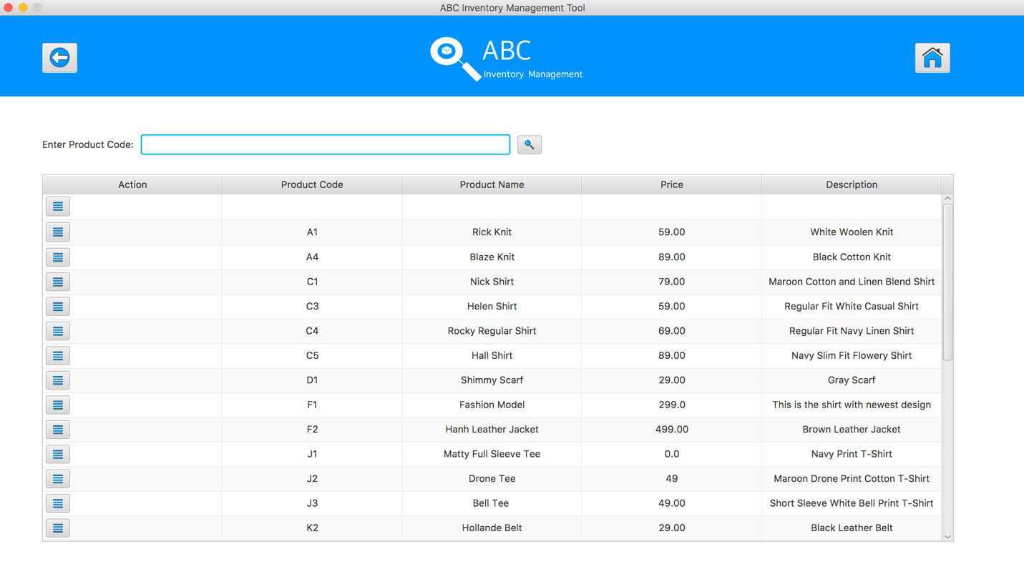

**Step 2:**

* User inputs “S1” to the Product Code field

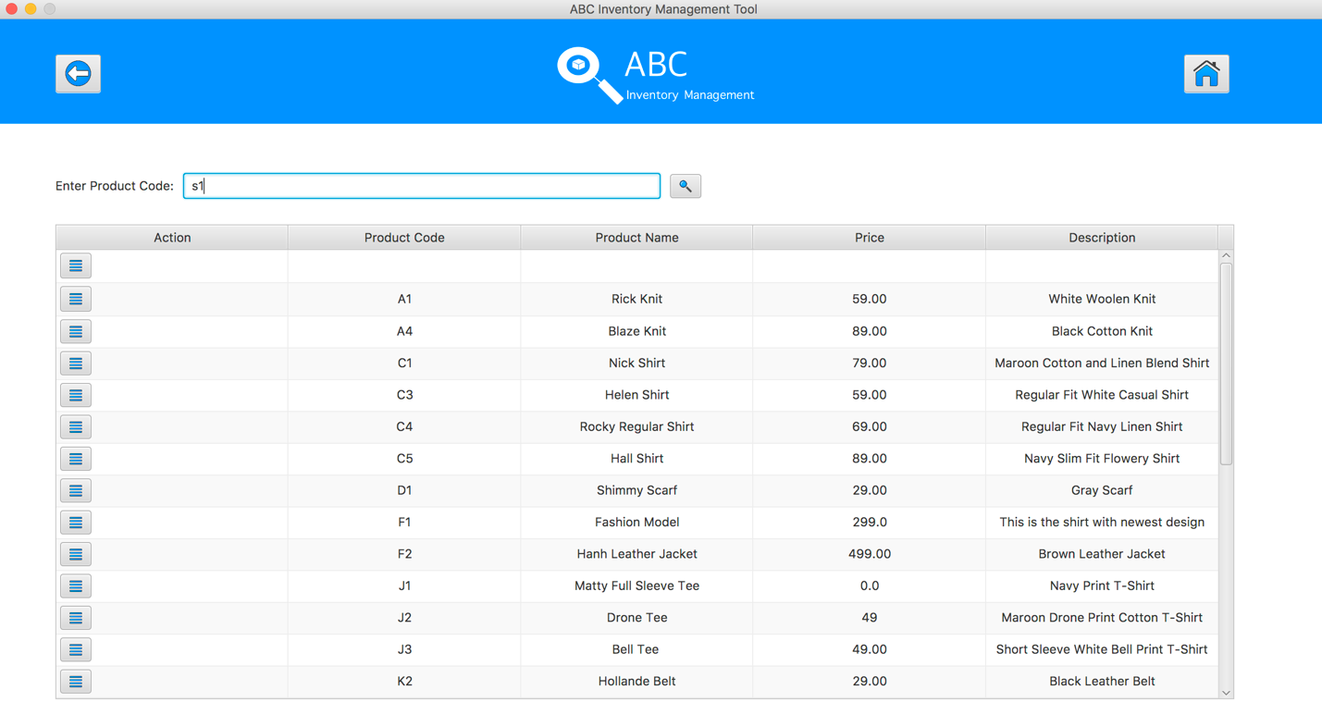

**Step 3:**

* System display the details of matched product and its information

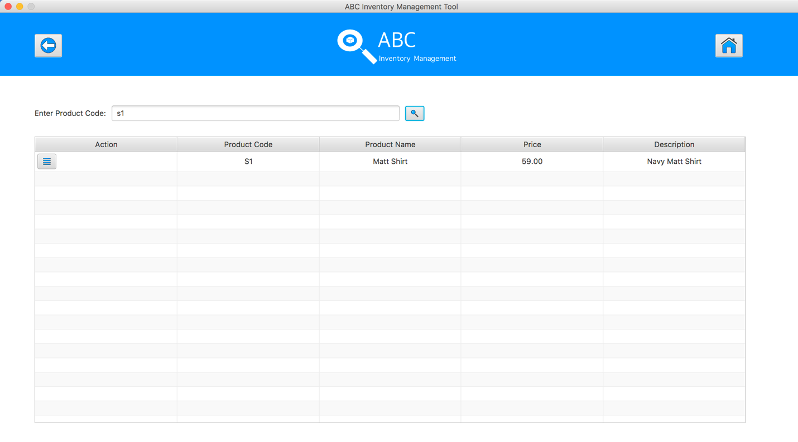

**Test Search Product Using Existing Product Code (Test Case SPT001) for Data Set 1:** **PASS**

### Data Set 2

|  |  |
| --- | --- |
| **Test Data Table** | |
|  | **Input Data** |
| **Product Code** | S2 |

**Step 1**

* User opens the Search Product interface



**Step 2**

* User inputs “S2” to the Product Code field

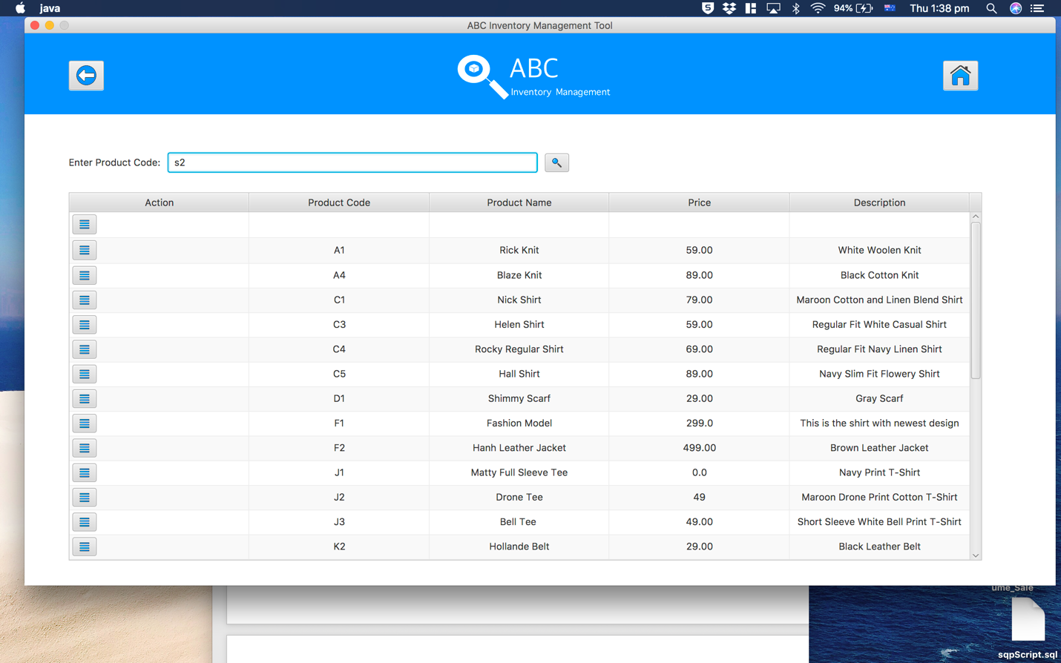

**Step 3**

* System display the details of matched product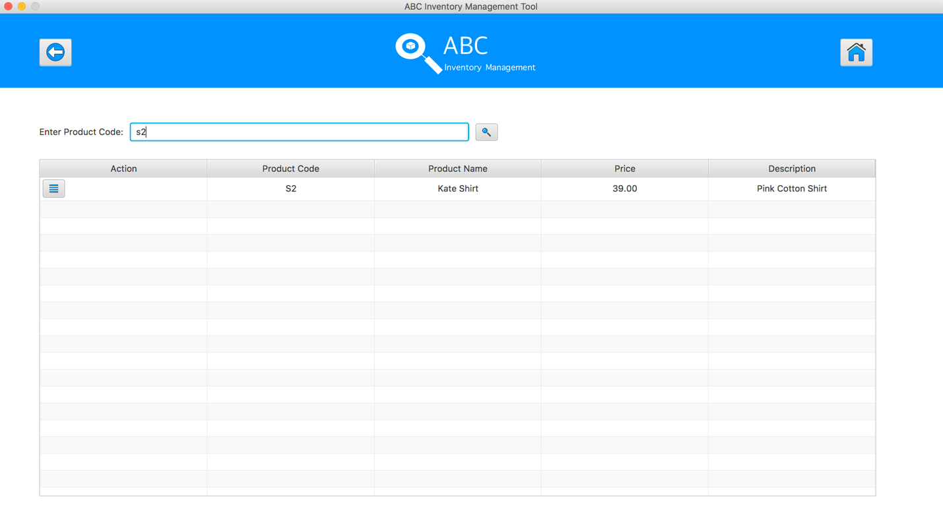

**Test Search Product Using Existing Product Code (Test Case SPT001) for Data Set 2:** **PASS**

# SPT002- Search Product Using Unknown Product Code

|  |  |  |  |  |  |
| --- | --- | --- | --- | --- | --- |
| **Test Name** | | Test Search Product Using Unknown Product Code (Test Case SPT002) | | | |
| **Use Case Tested** | | Search Product | | | |
| **Test Description** | | This test tests if the system can retrieve product item details. This random product code value can be of any format i.e. it does not have to follow the product code format that has been prescribed by the business. | | | |
| **Pre-Conditions** | | Meta data must exist, product and product details like product code, product name, description, price and so on must exist even though it may or may not be accessed which is based on the product code that will be entered. | | | |
| **Post-Conditions** | | If product code matches to the product code entry in the database, the matching product is. However, if product code does not match to any of the product code entry in the database, an appropriate message is displayed. | | | |
| **Notes** | | This test allows users to view product items using a product code.  This test shows appropriate messages are displayed for every user action (Addressing the usability requirement of the system). | | | |
| **Result (Pass/Fail/Warning/ Incomplete)** | | Pass | | | |
|  | **Test Step** | | **Expected Test Results** | **P** | **F** |
| 1. | Select Search Product Button from home page | | Display the Search Product page | P |  |
| 2. | Type in the product code in the product code field. | | System waits for the user to hit enter or click on the ‘Search’ button. | P |  |
| 3. | Hit enter or click on the ‘Search’ button. | | If product code matches with the product code entry in the database, product with matching product code is displayed with all other product details like product name, product code, price, description. | P |  |
|  |  | | If product code does not match with the product code entry in the database, an appropriate message is displayed notifying users that the product does not exist. | P |  |

## Result Screenshots

The screenshots of the result on each test step for each data set are given below:

### Data Set 1

|  |  |
| --- | --- |
| **Test Data Table** | |
|  | **Input Data** |
| **Product Code** | A321 |

**Step 1**

* User opens the Search Product interface



**Step 2**

* User inputs “A321” to the Product Code field

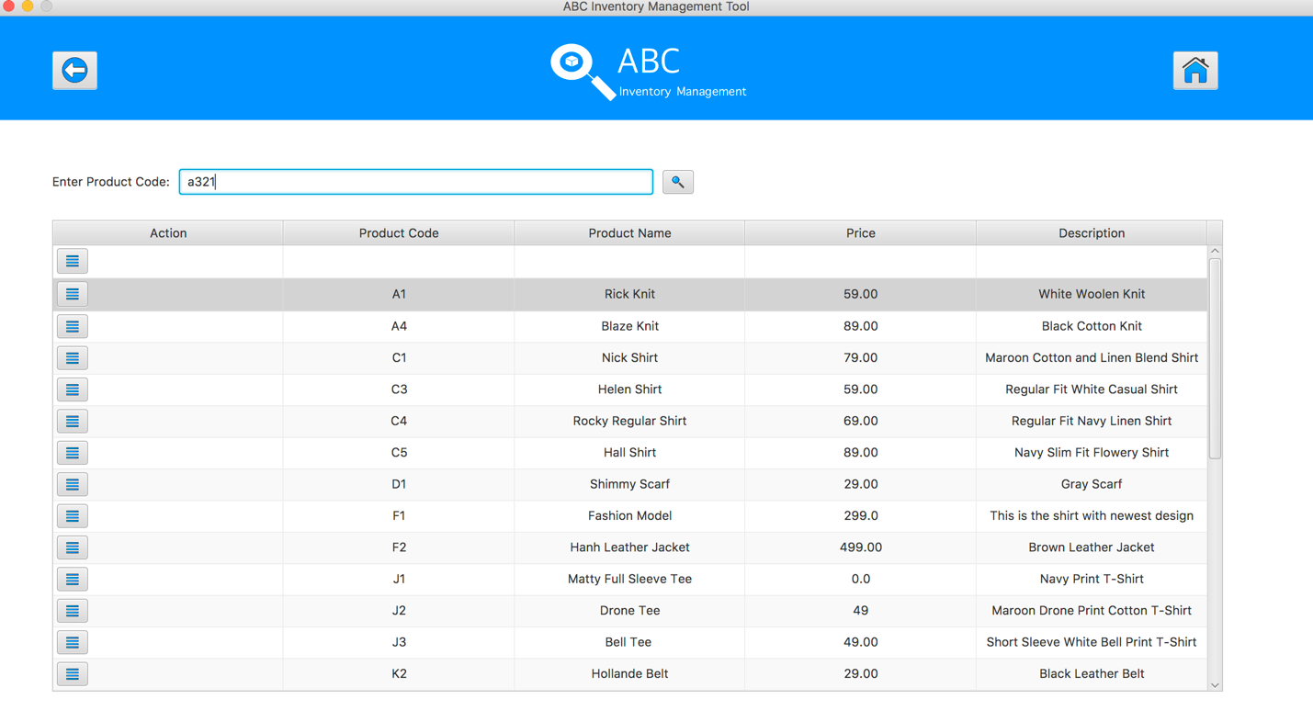

**Step 3**

* System pops up an alert to notify the searching Product Code does not exist.

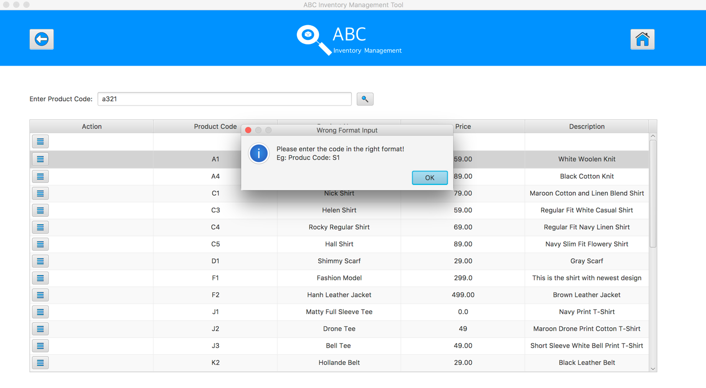

**SPT002- Search Product Using Unknown Product Code for Data Set 1: PASS**

### Data Set 2

|  |  |
| --- | --- |
| **Test Data Table** | |
|  | **Input Data** |
| **Product Code** | S5 |

**Step 1**

* User opens the Search Product interface



**Step 2**

* User inputs “S5” to the Product Code field

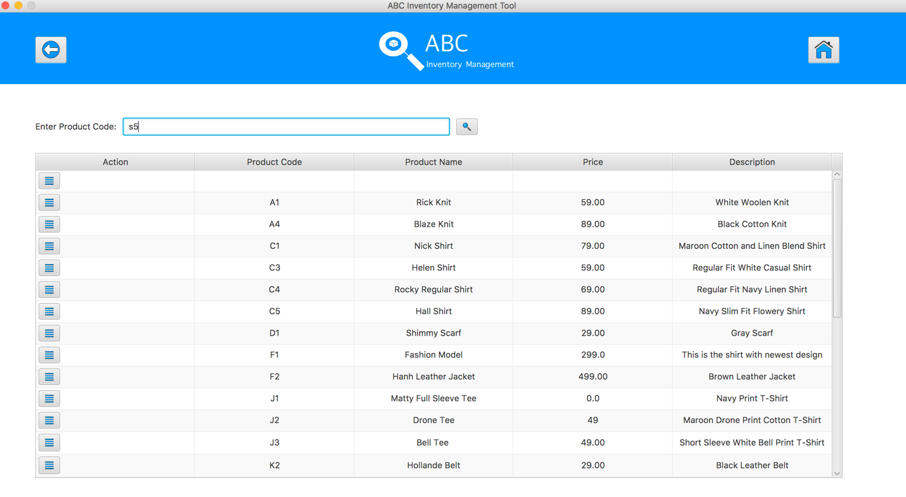

**Step 3**

* System pops up an alert to notify the searching Product Code does not exist.

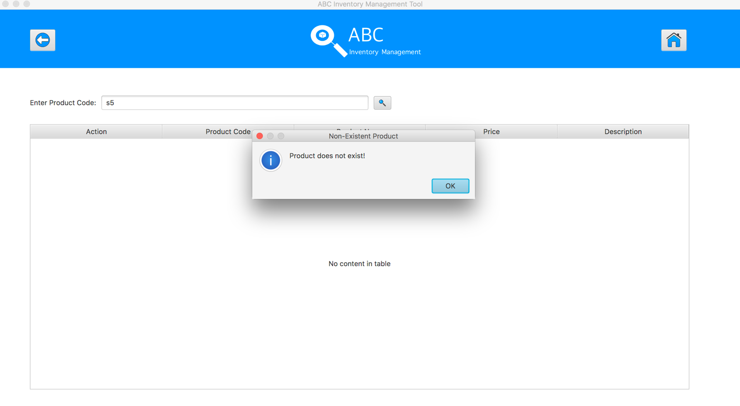

SPT002- Search Product Using Unknown Product Code for Data Set 2: PASS

# SPT003- Search Product Using Existing Product Item Code

|  |  |  |  |  |  |
| --- | --- | --- | --- | --- | --- |
| **Test Name** | | Test Search Product Using Existing Product Item Code (Test Case SPT003) | | | |
| **Use Case Tested** | | Search Product | | | |
| **Test Description** | | This test tests if the system can retrieve product item details and contents in selected product code using a known product item code. | | | |
| **Pre-Conditions** | | Meta data must exist, product and product details like product code, product item code, size and so on. | | | |
| **Post-Conditions** | | Matching product item on displayed through product item code i.e. matching product is displayed through which product item code has been searched. | | | |
| **Notes** | | This test assumes that the user knows the product item code exists. | | | |
| **Result (Pass/Fail/Warning/ Incomplete)** | | Pass | | | |
|  | **Test Step** | | **Expected Test Results** | **P** | **F** |
| 1. | Select Search Product Button from home page | | Display the Search Product page | P |  |
| 2. | Select a product by hit/ click on the “Show details of this product” button | | System display list of product items of selected product | P |  |
| 3. | Type in the existing product item code that is known by the user in the Product Item Code field of the system. | | System waits for the user to hit enter or click on the ‘Search’ button. | P |  |
| 4. | Hit enter or click on the ‘Search’ button. | | Product with matching product item code is displayed with all other product details like product item code, size, and “Detail” button. | P |  |
| 5. | Click on the “Detail” button of selected product item | | A list of detail about the location, quantity of this item in different location will be displayed | P |  |

## Result Screenshots

The screenshots of the result on each test step for each data set are given below:

### Data Set 1

|  |  |
| --- | --- |
| **Test Data Table** | |
|  | **Input Data** |
| **Product Code** | S1 |
| **Product Item Code** | S1100 |

**Step 1**

* Open the Search Product interface



**Step 2**

* User select a product code and hit “View details of this product” button.

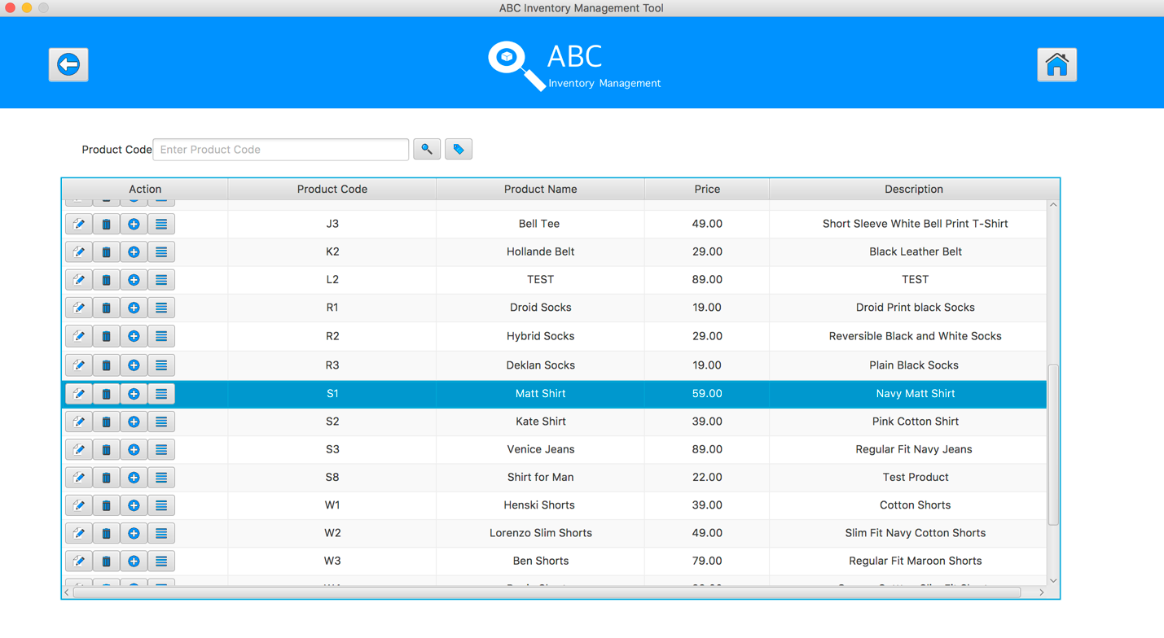

**Step 3**

* System displays the list of product item code of selected product

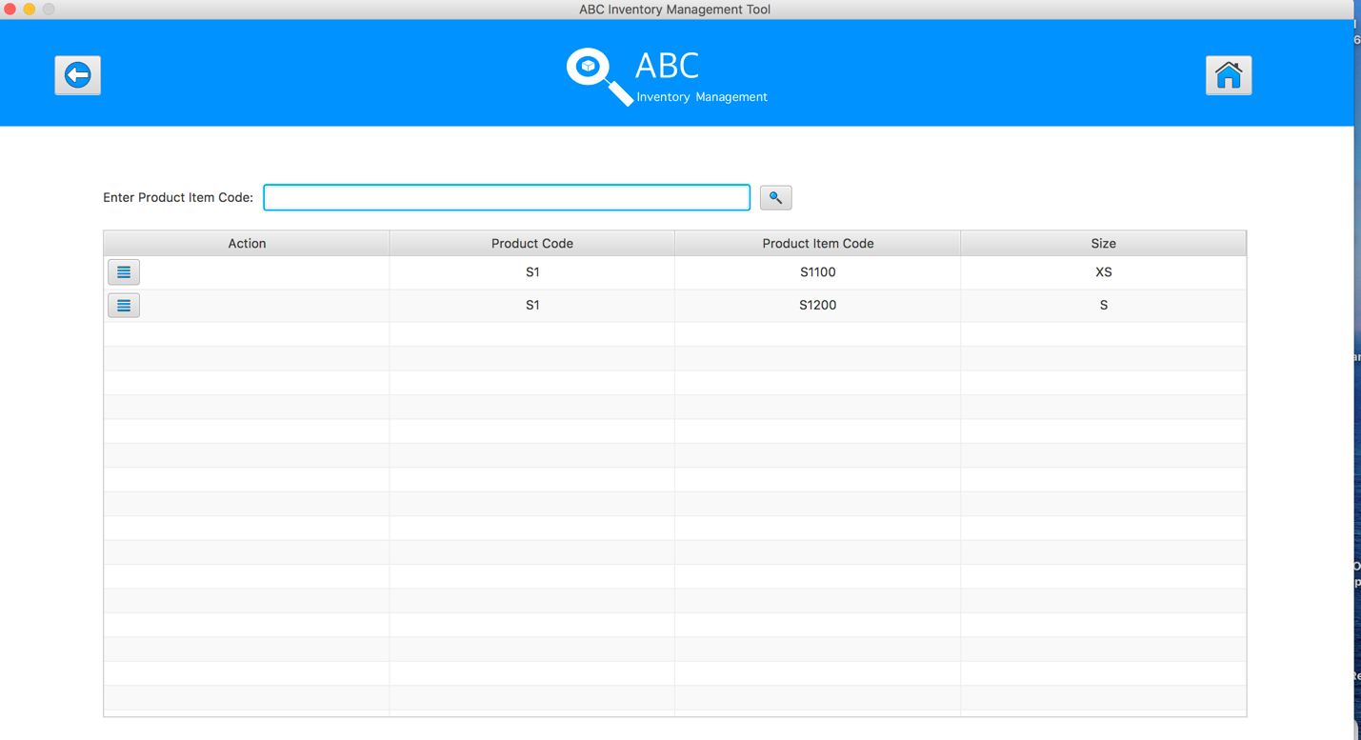

**Step 4**

* User input “s1100” and hit search button

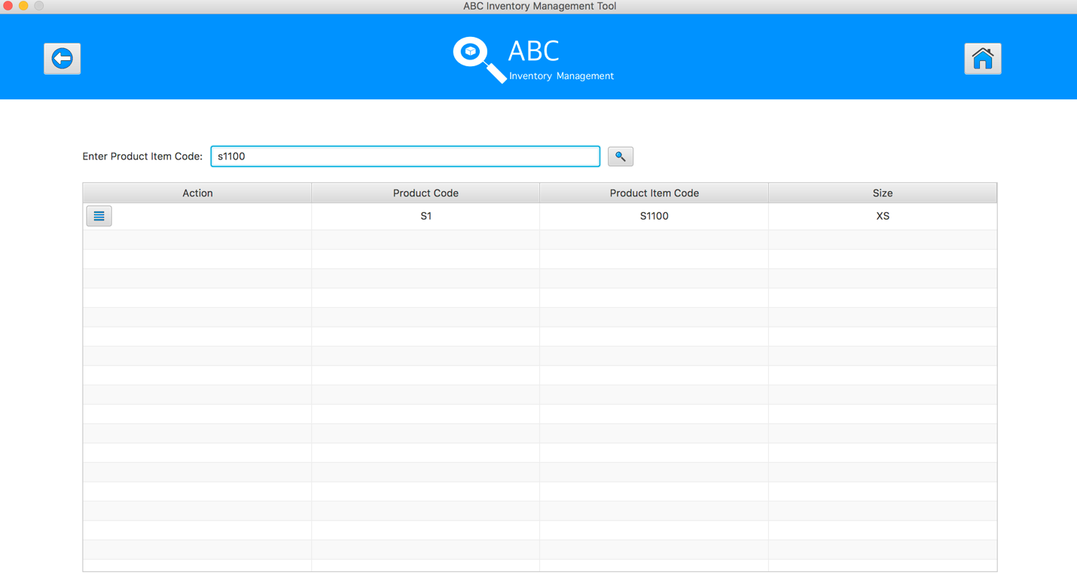

**Step 5**

* User clicks on to the the “Detail” button.
* A list of detail about the location, quantity of this item in different location will be displayed.

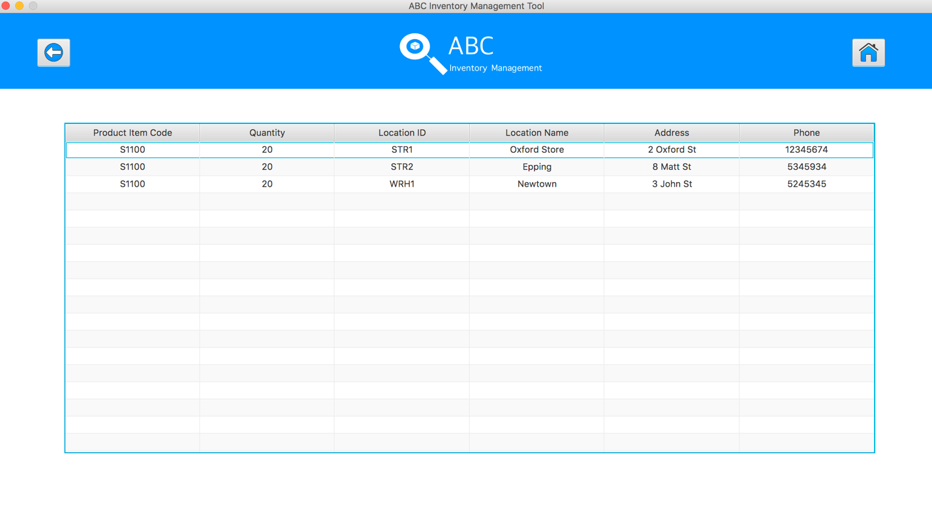

**SPT003- Search Product Using Existing Product Item Code for Data Set 1: PASS**

### Data Set 2

|  |  |
| --- | --- |
| **Test Data Table** | |
|  | **Input Data** |
| **Product Code** | S1 |
| **Product Item Code** | S1200 |

**Step 1**

* Open the Search Product interface



**Step 2**

* User select a product code and hit “View details of this product” button.



**Step 3**

* System displays the list of product item code of selected product



**Step 4**

* User input “s1200” and hit search button

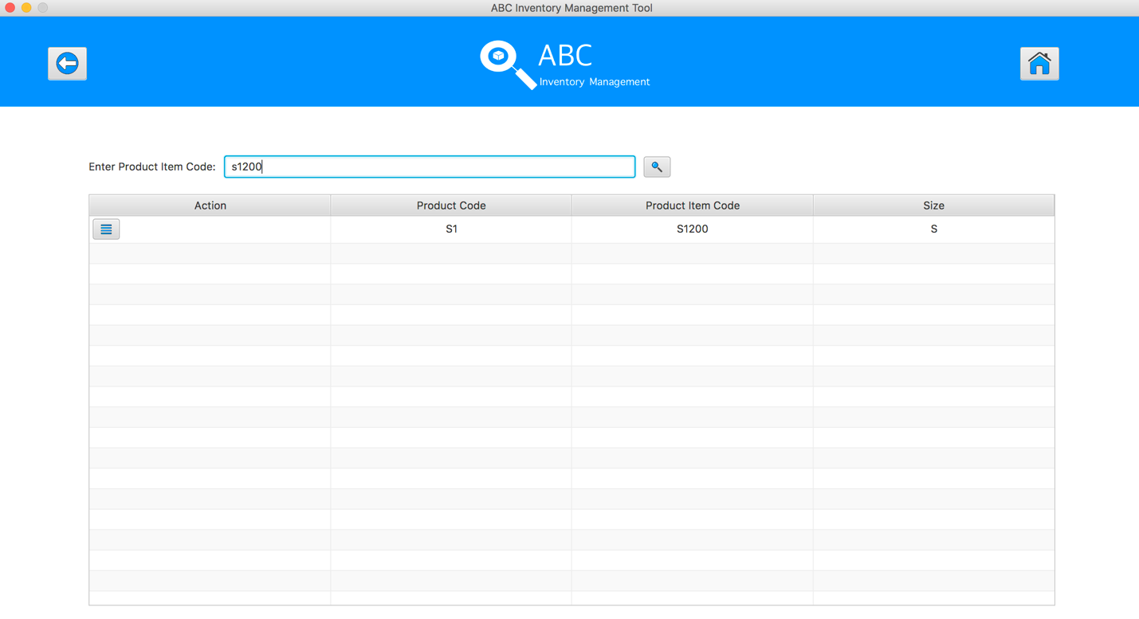

**Step 5**

* User clicks on to the the “Detail” button.
* A list of detail about the location, quantity of this item in different location will be displayed.

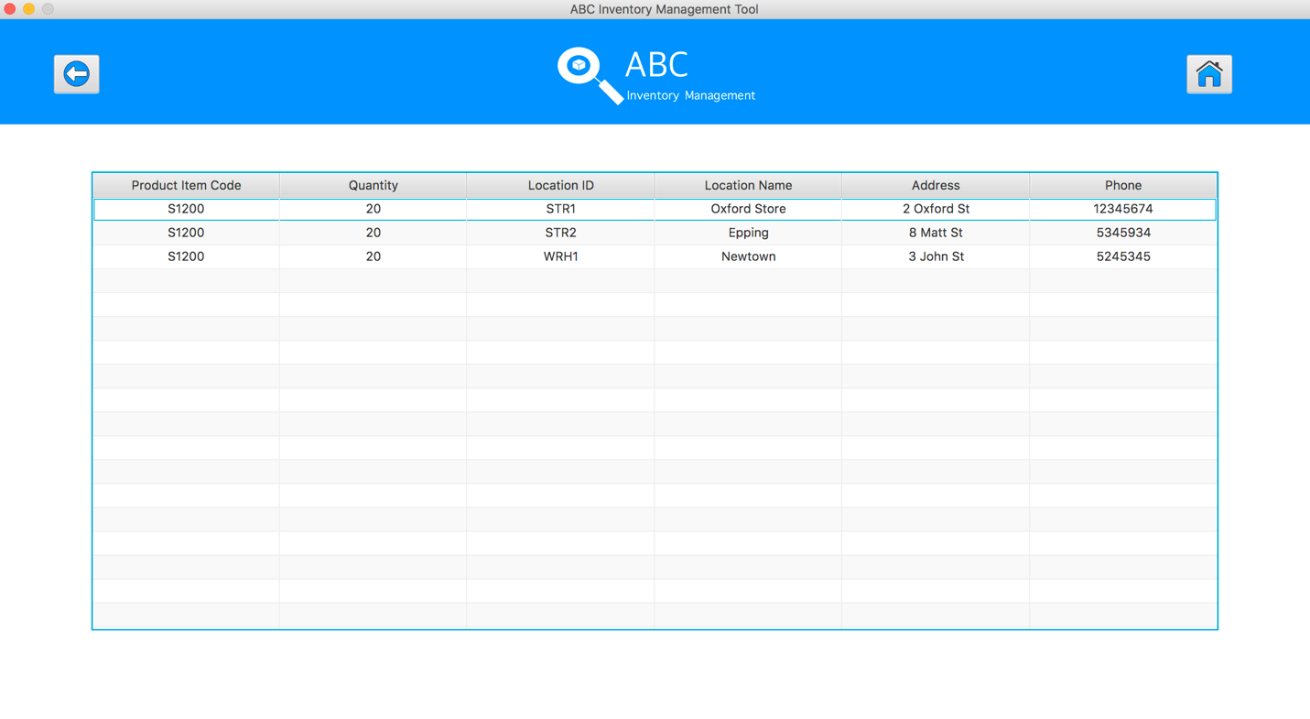

**SPT003- Search Product Using Existing Product Item Code for Data Set 2: PASS**

### Data Set 3

|  |  |
| --- | --- |
| **Test Data Table** | |
|  | **Input Data** |
| **Product Code** | S2 |
| **Product Item Code** | S2100 |

**Step 1**

* Open the Search Product interface



**Step 2**

* User select a product code and hit “View details of this product” button.

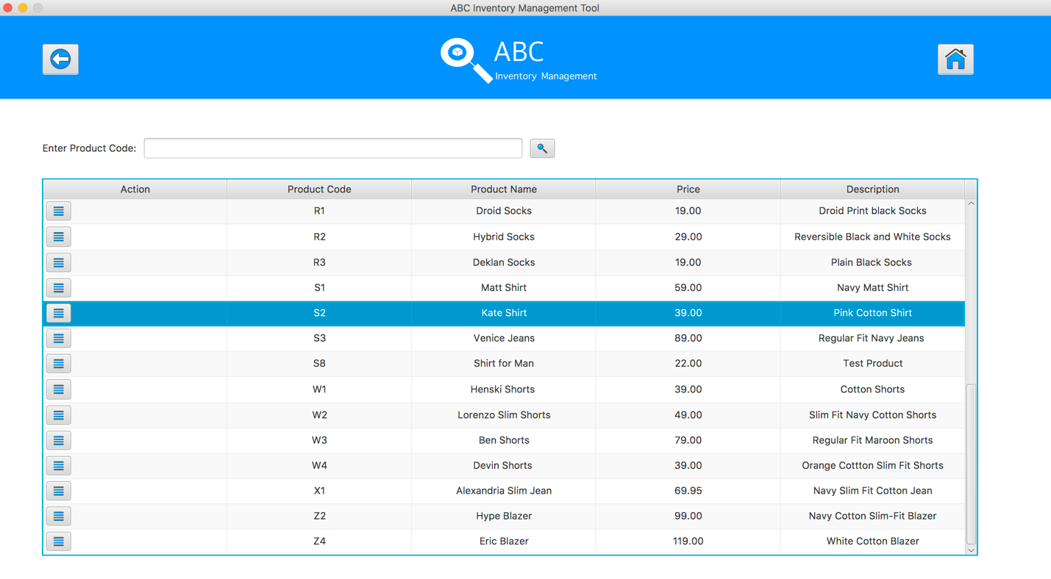

**Step 3**

* System displays the list of product item code of selected product

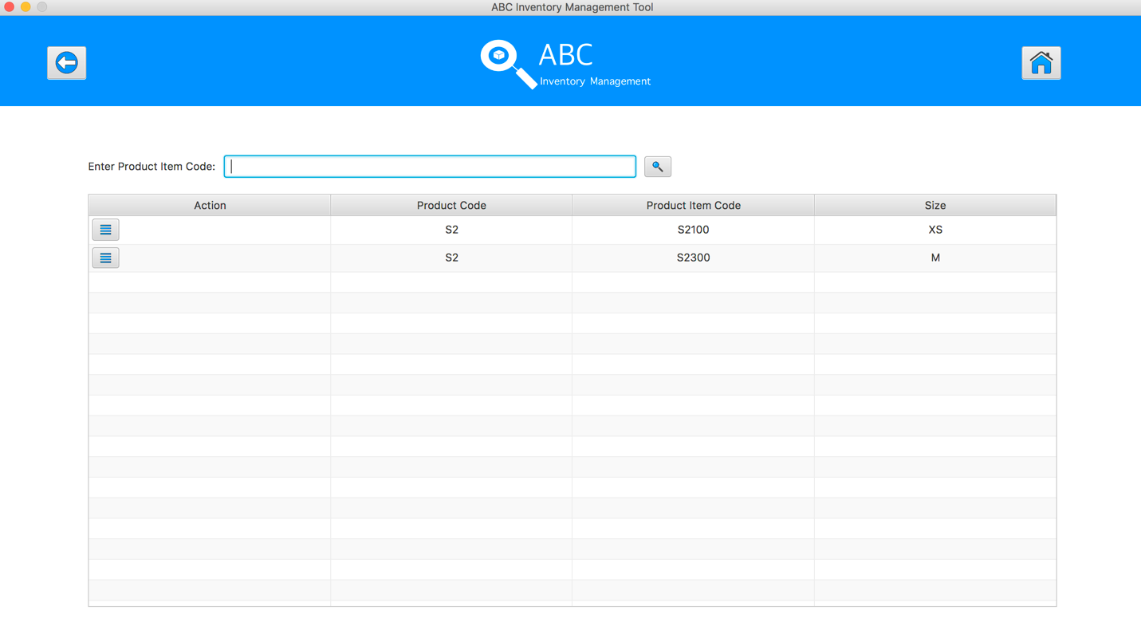

**Step 4**

* User input “s2100” and hit search button

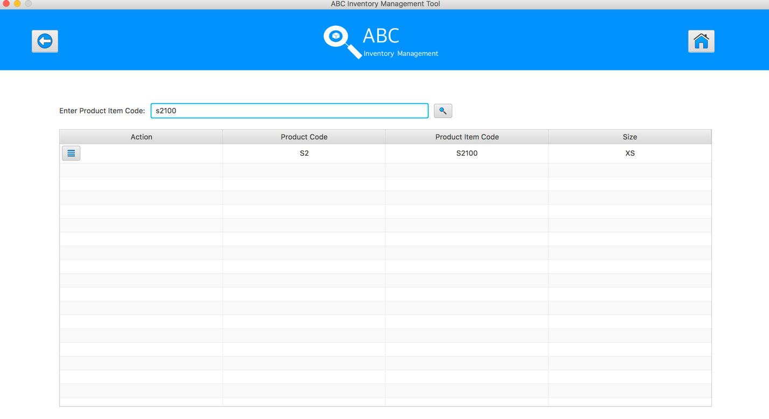

**Step 5**

* User clicks on to the the “Detail” button.
* A list of detail about the location, quantity of this item in different location will be displayed.

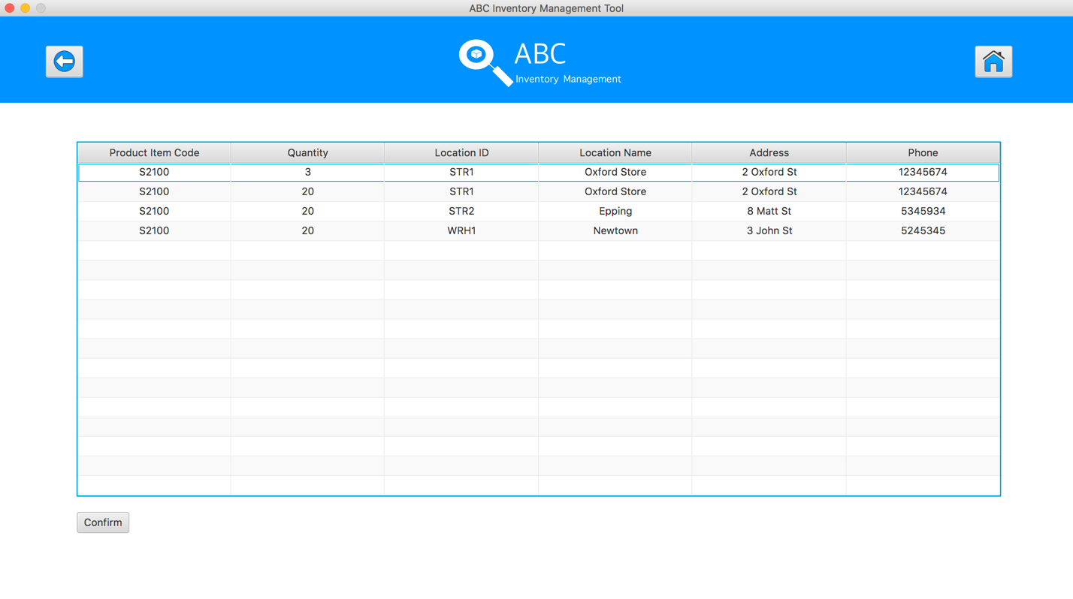

**SPT003- Search Product Using Existing Product Item Code for Data Set 3: PASS**

# SPT004- Search Product Using Unknown Product Item Code

|  |  |  |  |  |  |
| --- | --- | --- | --- | --- | --- |
| **Test Name** | | Test Search Product Using Unknown Product Item Code (Test Case SPT004) | | | |
| **Use Case Tested** | | Search Product | | | |
| **Test Description** | | This test tests if the system can retrieve product item details and contents in selected product code using an unknown product item code. | | | |
| **Pre-Conditions** | | Meta data must exist, product and product details like product code, product item code, size. | | | |
| **Post-Conditions** | | The alert will be popped up to display the message that notify user the searching product item code does not exist in system. | | | |
| **Notes** | | This test assumes that the user try to search the product item code randomly. | | | |
| **Result (Pass/Fail/Warning/ Incomplete)** | | Pass | | | |
|  | **Test Step** | | **Expected Test Results** | **P** | **F** |
| 1. | Select Search Product Button from home page | | Display the Search Product page | P |  |
| 2. | Select a product by hit/ click on the “Show details of this product” button | | System display list of product items of selected product | P |  |
| 3. | Type in the random product item code in the Product Item Code field of the system. | | System waits for the user to hit enter or click on the ‘Search’ button. | P |  |
| 4. | Hit enter or click on the ‘Search’ button. | | An alert message will be displayed to let user know the searching product item does not exist in system. | P |  |

## Result Screenshots

The screenshots of the result on each test step for each data set are given below:

### Data Set 1

|  |  |
| --- | --- |
| **Test Data Table** | |
|  | **Input Data** |
| **Product Code** | S1 |
| **Product Item Code** | SJSAJO |

**Step 1**

* Open the Search Product interface



**Step 2**

* User select a product code and hit “View details of this product” button.



**Step 3**

* System displays the list of product item code of selected product



**Step 4**

* User input “SJSAJO” and hit search button

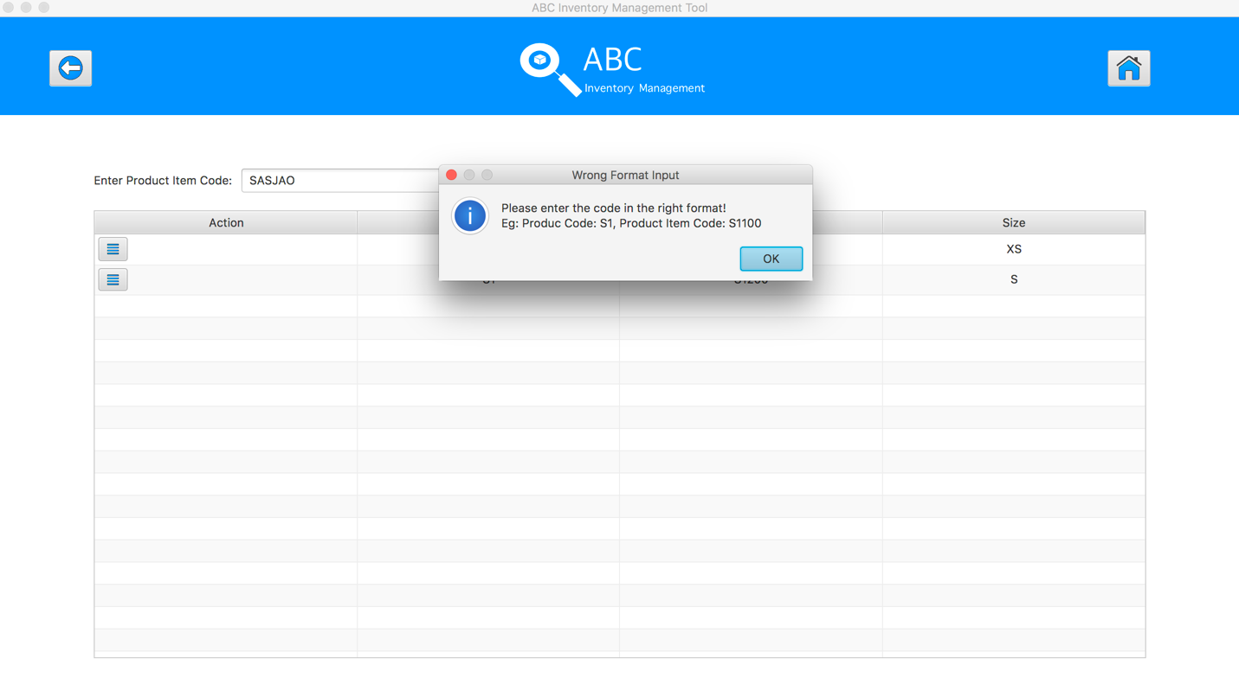

**SPT004- Search Product Using Unknown Product Item Code for Data Set 1: PASS**

### Data Set 2

|  |  |
| --- | --- |
| **Test Data Table** | |
|  | **Input Data** |
| **Product Code** | S2 |
| **Product Item Code** | S23022 |

**Step 1**

* Open the Search Product interface



**Step 2**

* User select a product code and hit “View details of this product” button.

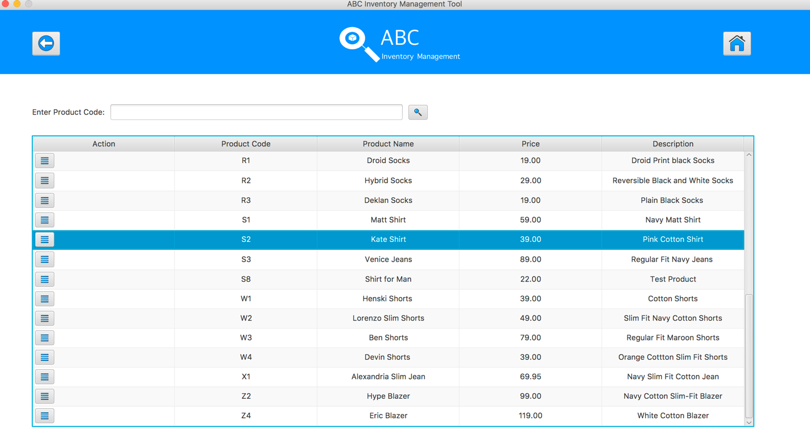

**Step 3**

* System displays the list of product item code of selected product

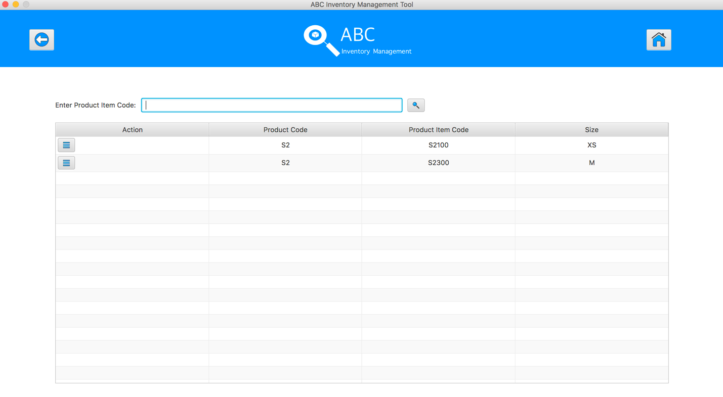

**Step 4**

* User input “S23022” and hit search button

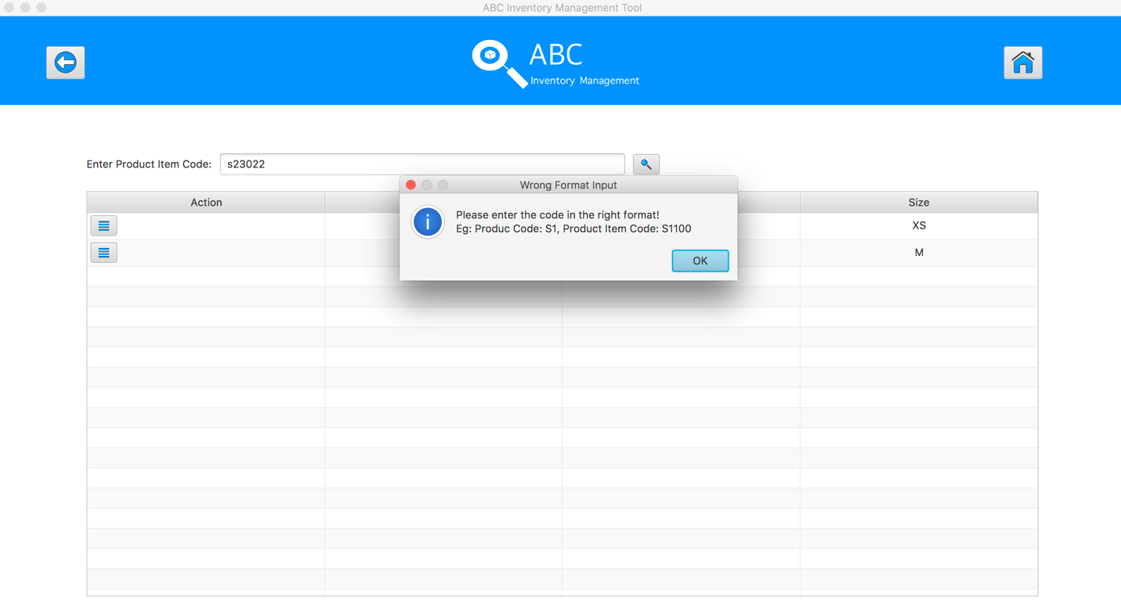

**SPT004- Search Product Using Unknown Product Item Code for Data Set 2: PASS**

### Data Set 3

|  |  |
| --- | --- |
| **Test Data Table** | |
|  | **Input Data** |
| **Product Code** | S2 |
| **Product Item Code** | S2AB |

**Step 1**

* Open the Search Product interface



**Step 2**

* User select a product code and hit “View details of this product” button.



**Step 3**

* System displays the list of product item code of selected product



**Step 4**

* User input “S2ab” and hit search button

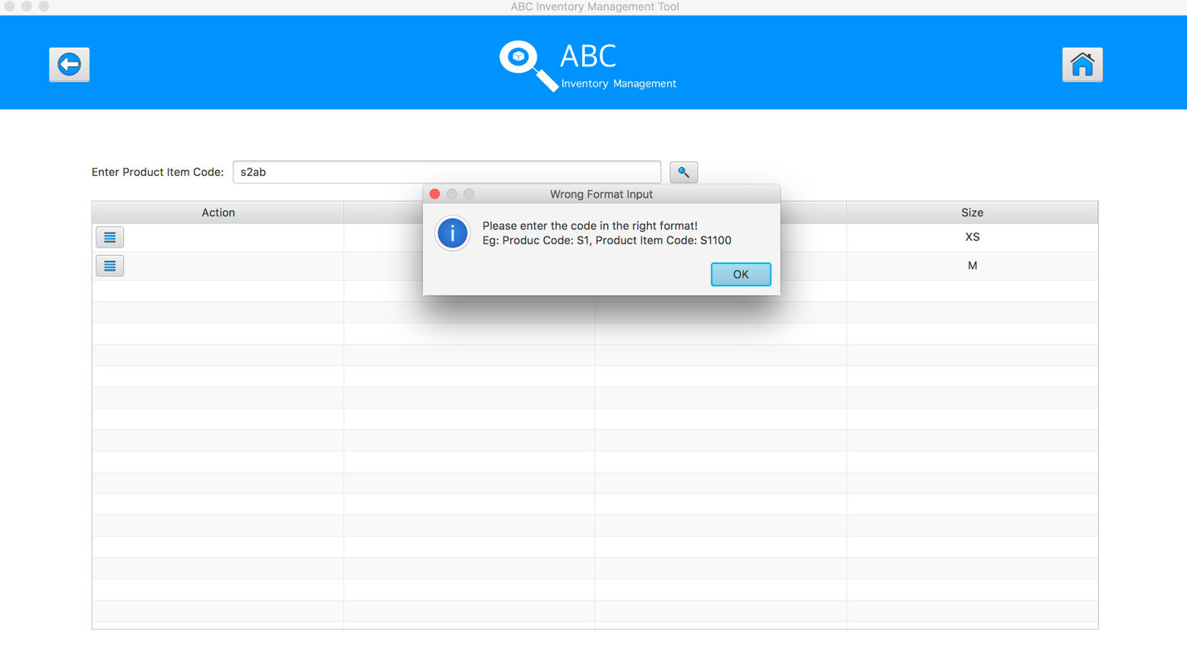

**SPT004- Search Product Using Unknown Product Item Code for Data Set 3: PASS**